Assignment no 6

1)Write two different queries that would produce all orders taken on October 3rd or 4th,1990.

Ans -

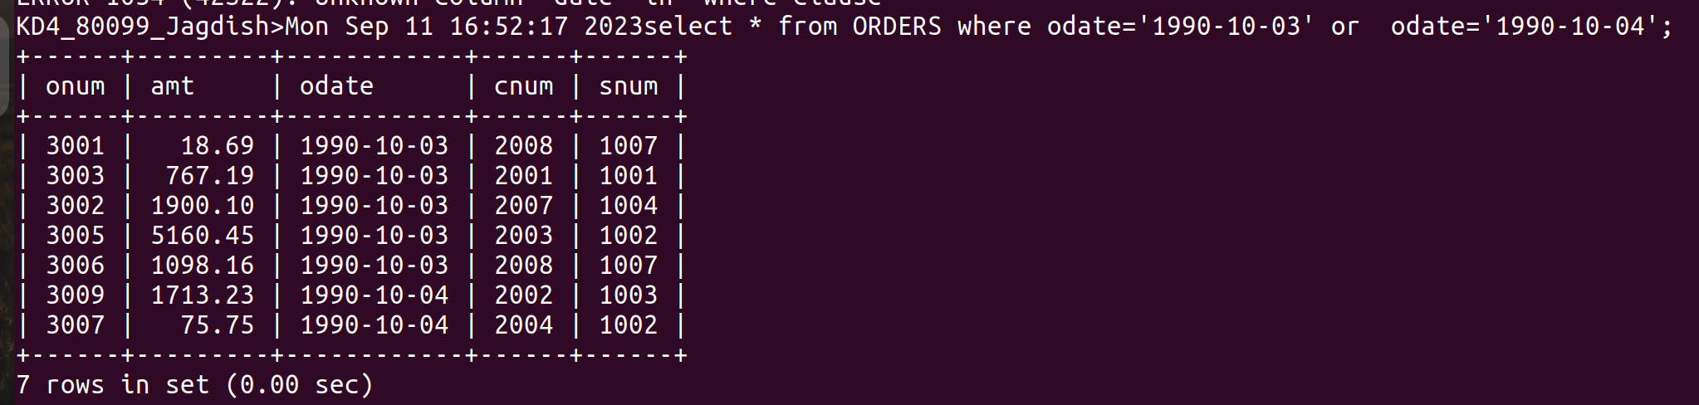

2)Write a querry that Selects all of the customers serviced by Peel or Motika.

Ans-

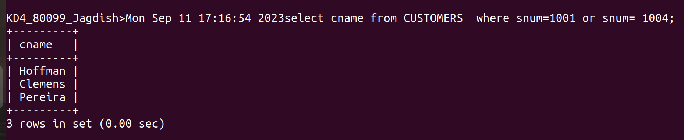

3)Write a query that will produce all the customers whose names begin with letter from’A’ to ‘G’.

Ans-

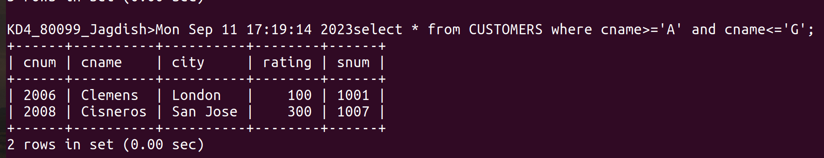
4) Write a Query that selects all customers whose names begin with the letter ‘C’.

Ans-

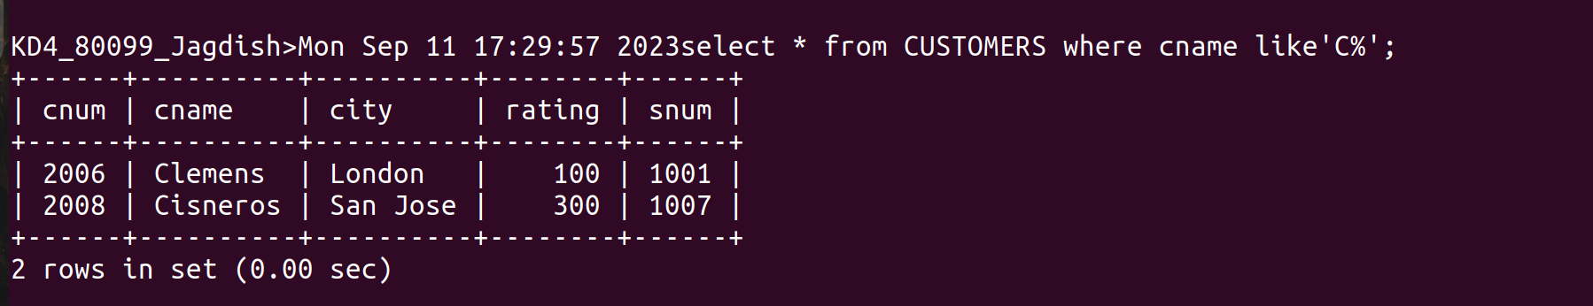
5) Write a query that selects all orders except those with zeroes or nulls in the amt field.

Ans-

